BATTING BASE: START: SPIRITUAL BIRTH:
Knowing Christ; Infant Stage

MODULE 1: NEW LIFE LESSONS

LESSON 7: WITNESS

INTRODUCTION

REVIEW:

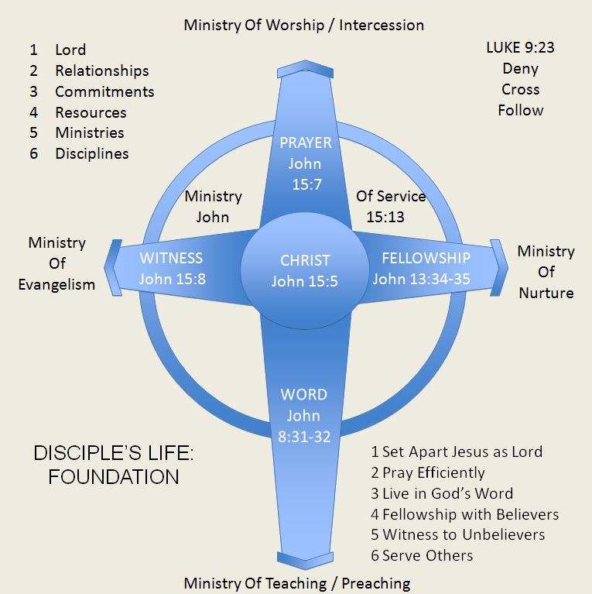

FOUNDATIONAL PRINCIPLES IN BEING EFFECTIVE WITNESSES FOR CHRIST

1. Be ______________

2. Be ______________

3. Be ____________________________

John 6:44
King James Version (KJV)
⁴⁴ No man can come to me, except the Father which hath sent me draw him: and I will raise him up at the last day.

Romans 1:16
King James Version (KJV)
¹⁶ For I am not ashamed of the gospel of Christ: for it is the power of God unto salvation to every one that believeth; to the Jew first, and also to the Greek.

Romans 10:13-14
King James Version (KJV)
¹³ For whosoever shall call upon the name of the Lord shall be saved.
¹⁴ How then shall they call on him in whom they have not believed? and how shall they believe in him of whom they have not heard? and how shall they hear without a preacher?

We are His ______________

Acts 1:8
King James Version (KJV)
⁸ But ye shall receive power, after that the Holy Ghost is come upon you: and ye shall be witnesses unto me both in Jerusalem, and in all Judaea, and in Samaria, and unto the uttermost part of the earth.

Ezekiel 3:17-21
King James Version (KJV)
¹⁷ Son of man, I have made thee a watchman unto the house of Israel: therefore hear the word at my mouth, and give them warning from me.
¹⁸ When I say unto the wicked, Thou shalt surely die; and thou givest him not warning, nor speakest to warn the wicked from his wicked way, to save his life; the same wicked man shall die in his iniquity; but his blood will I require at thine hand.
¹⁹ Yet if thou warn the wicked, and he turn not from his wickedness, nor from his wicked way, he shall die in his iniquity; but thou hast delivered thy soul.
²⁰ Again, When a righteous man doth turn from his righteousness, and commit iniquity, and I lay a stumbling-block before him, he shall die: because thou hast not given him warning, he shall die in his sin, and his righteousness which he hath done shall not be remembered; but his blood will I require at thine hand.
²¹ Nevertheless if thou warn the righteous man, that the righteous sin not, and he doth not sin, he shall surely live, because he is warned; also thou hast delivered thy soul.

Mark 16:15
King James Version (KJV)
¹⁵ And he said unto them, Go ye into all the world, and preach the gospel to every creature.

We ought to ______________

I. SHARING CHRIST WITH YOUR ______________________

Acts 26:1-29

A. YOUR LIFE BEFORE CHRIST

B. HOW YOU CAME TO KNOW CHRIST

C. YOUR LIFE AFTER RECEIVING CHRIST

II. SHARING CHRIST THROUGH ___________________________________

A. SHARE CHRIST THROUGH THE BOOKLET

1. Take advantage of the benefits of using a booklet

a. Easy

b. Clear

c. Small

d. Concise

e. Givable

f. Transferable

2. Introduce the booklet efficiently

John 4:7-14
King James Version (KJV)
⁷ There cometh a woman of Samaria to draw water: Jesus saith unto her, Give me to drink.
⁸ (For his disciples were gone away unto the city to buy meat.)
⁹ Then saith the woman of Samaria unto him, How is it that thou, being a Jew, askest drink of me, which am a woman of Samaria? for the Jews have no dealings with the Samaritans.
¹⁰ Jesus answered and said unto her, If thou knewest the gift of God, and who it is that saith to thee, Give me to drink; thou wouldest have asked of him, and he would have given thee living water.
¹¹ The woman saith unto him, Sir, thou hast nothing to draw with, and the well is deep: from whence then hast thou that living water?
¹² Art thou greater than our father Jacob, which gave us the well, and drank thereof himself, and his children, and his cattle?
¹³ Jesus answered and said unto her, Whosoever drinketh of this water shall thirst again:
¹⁴ But whosoever drinketh of the water that I shall give him shall never thirst; but the water that I shall give him shall be in him a well of water springing up into everlasting life.

3. Present the booklet appropriately

a. Hold the booklet steady between both of you.
b. Maintain the person’s attention by pointing to relevant words or
illustrations as you read.
c. Simply read through the booklet!

B. SHARE CHRIST WHILE SKETCHING

Prepare Well

a. Topics
b. Scriptures
c. Flow
d. Pray

C. SHARE CHRIST AFTER A PRESENTATION

FOUR QUESTIONS TO INTRODUCE THE GOSPEL

1. Focus: the material

What did you think about the (booklet, video, concert, etc.)?

2. Focus: the material in connection with the audience

Did it make sense to you?

3. Focus: the audience

a. In relation to the Christ

Have you ever trusted Christ to forgive your sins as presented by the (booklet, video, drama, concert, etc.)?

b. In response to Christ

You would like to wouldn’t you?

III. SHARE CHRIST DIRECTLY FROM THE ___________________

Acts 8:26-35
King James Version (KJV)
²⁶ And the angel of the Lord spake unto Philip, saying, Arise, and go toward the south unto the way that goeth down from Jerusalem unto Gaza, which is desert.
²⁷ And he arose and went: and, behold, a man of Ethiopia, an eunuch of great authority under Candace queen of the Ethiopians, who had the charge of all her treasure, and had come to Jerusalem for to worship,
²⁸ Was returning, and sitting in his chariot read Esaias the prophet.
²⁹ Then the Spirit said unto Philip, Go near, and join thyself to this chariot.
³⁰ And Philip ran thither to him, and heard him read the prophet Esaias, and said, Understandest thou what thou readest?
³¹ And he said, How can I, except some man should guide me? And he desired Philip that he would come up and sit with him.
³² The place of the scripture which he read was this, He was led as a sheep to the slaughter; and like a lamb dumb before his shearer, so opened he not his mouth:
³³ In his humiliation his judgment was taken away: and who shall declare his generation? for his life is taken from the earth.
³⁴ And the eunuch answered Philip, and said, I pray thee, of whom speaketh the prophet this? of himself, or of some other man?
³⁵ Then Philip opened his mouth, and began at the same scripture, and preached unto him Jesus.

A. PREPARE THE SCRIPTURES TO USE

1. Four Spiritual Laws

2. Romans Road

a. All Scriptures are taken from Romans

IV. SHARE CHRIST THROUGH ____________________

A. PEOPLE ARE OPEN TO PRAYER

Colossians 4:5
King James Version (KJV)
⁵ Walk in wisdom toward them that are without, redeeming the time.

B. BELIEVERS OUGHT TO BE INTENTIONAL IN PRAYING

1. With them for their needs

a. Their requests

b. Non-spiritual

c. Spiritual needs

2. Without them for salvation

Pray that God draws them to Himself and look for opportunities to share Christ with them as God provides.

a. Keep a journal of prayer requests and answers.

b. Record the dates the requests were received and answered.

c. Pray diligently for each request expecting God to work in
people’s lives!

d. Find out if God is answering your prayers and look for
opportunities to share His love!

