BATTING BASE: START: SPIRITUAL BIRTH:
Knowing Christ; Infant Stage

MODULE 1: NEW LIFE LESSONS

LESSON 4: WORD OF GOD

INTRODUCTION

REVIEW:

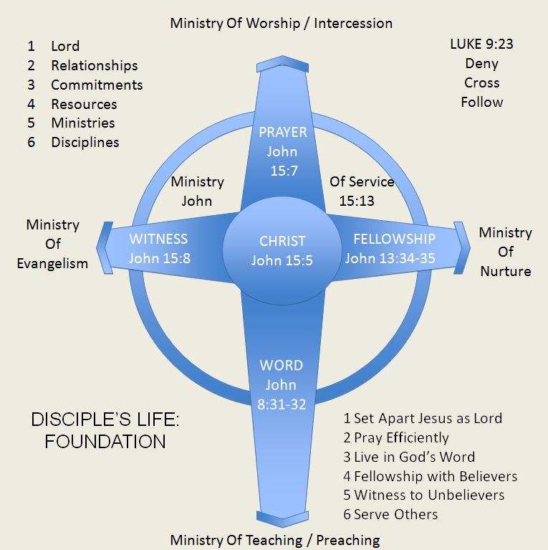

Hebrews 5:12
King James Version (KJV)
¹² For when for the time ye ought to be teachers, ye have need that one teach you again which be the first principles of the oracles of God; and are become such as have need of milk, and not of strong meat.

1 Peter 2:2
King James Version (KJV)
² As newborn babes, desire the sincere milk of the word, that ye may grow thereby:

BIBLE: Basic Instructions Before Leaving Earth

I. THE ________________ OF GOD’S WORD

A. GOD ______________ THE PROPHETS

2 Peter 1:20-21
King James Version (KJV)
²⁰ Knowing this first, that no prophecy of the scripture is of any private interpretation.
²¹ For the prophecy came not in old time by the will of man: but holy men of God spake as they were moved by the Holy Ghost.

B. GOD _____________ THE WRITERS

2 Timothy 3:16-17
King James Version (KJV)
¹⁶ All scripture is given by inspiration of God, and is profitable for doctrine, for reproof, for correction, for instruction in righteousness:
¹⁷ That the man of God may be perfect, thoroughly furnished unto all good works.

God authored it; humans wrote it

II. THE ______________________ OF GOD’S WORD

2 Timothy 3:16-17
King James Version (KJV)
¹⁶ All scripture is given by inspiration of God, and is profitable for doctrine, for reproof, for correction, for instruction in righteousness:
¹⁷ That the man of God may be perfect, thoroughly furnished unto all good works.

A. FOR ______________

B. FOR ______________

C. FOR ______________

D. FOR ______________ IN RIGHTEOUSNESS

THE OVERARCHING PURPOSE:

2 Timothy 3:17
King James Version (KJV)
¹⁷ That the man of God may be perfect, thoroughly furnished unto all good works.

MORE SPECIFIC PURPOSES

E. FOR ______________

(Just read the reference verses for each)

1 Peter 1:23

F. FOR ______________

1 Peter 2:2

G. FOR ______________

Psalm 19:7

H. FOR ____________________________

John 17:17

I. FOR ______________

John 8:31-32

J. FOR ______________
Psalm 19:8

K. FOR ______________

Psalm 19:11

L. FOR ____________________________ (AGAINST SIN)

Psalm 119:11

M. FOR ______________

Psalm 119:28

F. FOR ______________

Psalm 119:154

G. FOR ______________

Psalm 119:97-100

H. FOR ______________

Colossians 3:16

III. _____________________TO GOD’S WORD

AS PORTRAYED BY THE PARABLE OF THE SOWER

A. WE ______________ IT

B. WE __________________________________________ABOUT IT

C. WE DON’T _________________ IT

D. WE ______________ IT

IV. THE ____________________ OF GOD’S WORD

A. LAMP AND LIGHT

Psalm 119:105
King James Version (KJV)
¹⁰⁵ Thy word is a lamp unto my feet, and a light unto my path.

B. SWORD

Ephesians 6:17
King James Version (KJV)
¹⁷ And take the helmet of salvation, and the sword of the Spirit, which is the word of God:

Hebrews 4:12
King James Version (KJV)
¹² For the word of God is quick, and powerful, and sharper than any twoedged sword, piercing even to the dividing asunder of soul and spirit, and of the joints and marrow, and is a discerner of the thoughts and intents of the heart.

Matthew 4:1-11
King James Version (KJV)
⁴ But he answered and said, It is written, Man shall not live by bread alone, but by every word that proceedeth out of the mouth of God.

⁷ Jesus said unto him, It is written again, Thou shalt not tempt the Lord thy God.

¹⁰ Then saith Jesus unto him, Get thee hence, Satan: for it is written, Thou shalt worship the Lord thy God, and him only shalt thou serve.

IV. ___________________________ THE WORD OF GOD

A. HEARING

Romans 10:17
King James Version (KJV)
¹⁷ So then faith cometh by hearing, and hearing by the word of God.

B. READING

Matthew 21:42
King James Version (KJV)
⁴² Jesus saith unto them, Did ye never read in the scriptures, The stone which the builders rejected, the same is become the head of the corner: this is the Lord's doing, and it is marvellous in our eyes?

C. STUDYING

2 Timothy 2:15
King James Version (KJV)
¹⁵ Study to shew thyself approved unto God, a workman that needeth not to be ashamed, rightly dividing the word of truth.

Acts 17:11
King James Version (KJV)
¹¹ These were more noble than those in Thessalonica, in that they received the word with all readiness of mind, and searched the scriptures daily, whether those things were so.

D. MEDITATING

Psalm 1:1-3
King James Version (KJV)
1 Blessed is the man that walketh not in the counsel of the ungodly, nor standeth in the way of sinners, nor sitteth in the seat of the scornful.
² But his delight is in the law of the Lord; and in his law doth he meditate day and night.
³ And he shall be like a tree planted by the rivers of water, that bringeth forth his fruit in his season; his leaf also shall not wither; and whatsoever he doeth shall prosper.

Joshua 1:8
King James Version (KJV)
⁸ This book of the law shall not depart out of thy mouth; but thou shalt meditate therein day and night, that thou mayest observe to do according to all that is written therein: for then thou shalt make thy way prosperous, and then thou shalt have good success.

E. MEMORIZING

Psalm 119:11
King James Version (KJV)
¹¹ Thy word have I hid in mine heart, that I might not sin against thee.

F. PRACTICING

James 1:22-23
King James Version (KJV)
²² But be ye doers of the word, and not hearers only, deceiving your own selves.
²³ For if any be a hearer of the word, and not a doer, he is like unto a man beholding his natural face in a glass:

V. ________________________ THE WORD OF GOD

SUGGESTED DAILY HABIT TO DEVELOP

S Scriptures

Psalm 1:1-3
King James Version (KJV)
1 Blessed is the man that walketh not in the counsel of the ungodly, nor standeth in the way of sinners, nor sitteth in the seat of the scornful.
² But his delight is in the law of the Lord; and in his law doth he meditate day and night.
³ And he shall be like a tree planted by the rivers of water, that bringeth forth his fruit in his season; his leaf also shall not wither; and whatsoever he doeth shall prosper.

Psalm 32:8
King James Version (KJV)
⁸ I will instruct thee and teach thee in the way which thou shalt go: I will guide thee with mine eye.

O Observation

Jeremiah 29:13
King James Version (KJV)
¹³ And ye shall seek me, and find me, when ye shall search for me with all your heart.

John 5:38-40
King James Version (KJV)
³⁸ And ye have not his word abiding in you: for whom he hath sent, him ye believe not.
³⁹ Search the scriptures; for in them ye think ye have eternal life: and they are they which testify of me.
⁴⁰ And ye will not come to me, that ye might have life.

Acts 17:11
King James Version (KJV)
¹¹ These were more noble than those in Thessalonica, in that they received the word with all readiness of mind, and searched the scriptures daily, whether those things were so.

A Application

John 13:17
King James Version (KJV)
¹⁷ If ye know these things, happy are ye if ye do them.

James 1:22-23
King James Version (KJV)
²² But be ye doers of the word, and not hearers only, deceiving your own selves.
²³ For if any be a hearer of the word, and not a doer, he is like unto a man beholding his natural face in a glass:

P Prayer

John 15:7
King James Version (KJV)
⁷ If ye abide in me, and my words abide in you, ye shall ask what ye will, and it shall be done unto you.

1 John 5:14
King James Version (KJV)
¹⁴ And this is the confidence that we have in him, that, if we ask any thing according to his will, he heareth us:

VI. _____________________ THE WORD OF GOD

See James 1:22-23

Matthew 12:50
King James Version (KJV)
⁵⁰ For whosoever shall do the will of my Father which is in heaven, the same is my brother, and sister, and mother.

Luke 6:46
King James Version (KJV)
⁴⁶ And why call ye me, Lord, Lord, and do not the things which I say?

SUGGESTED GUIDE

S Sins to confess

P Promises to claim

A Attitudes or actions to adopt or avoid

C Commands to obey

E Examples to follow

MORE DETAILS

P Prayers to pray

E Errors to avoid

T Truths to believe

S Something to thank God for

