BATTING BASE: START: SPIRITUAL BIRTH:
Knowing Christ; Infant Stage

MODULE 1: NEW LIFE LESSONS
LESSON 4: PRAYER
INTRODUCTION

REVIEW:

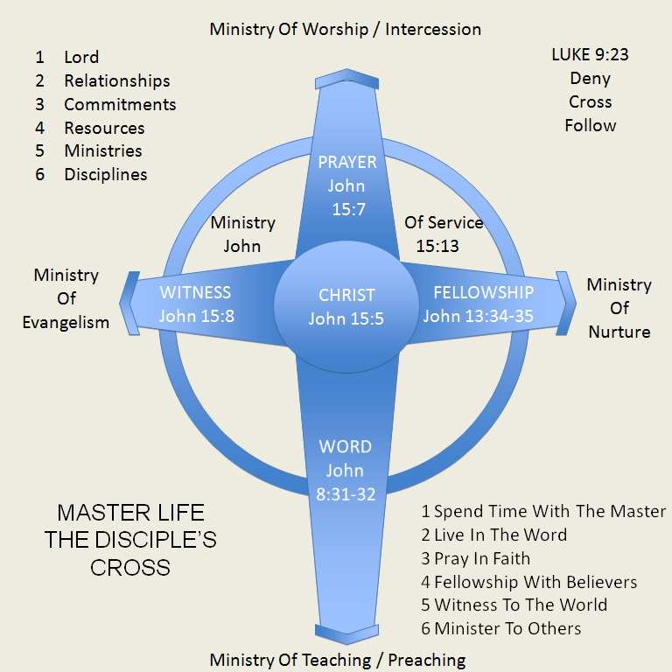

“Bless us Oh Lord, and these thy gifts, which we are about to receive, from thy bounty, through Christ, Our Lord. Amen.”

BIBLE EXAMPLES OF PEOPLE WHO PRAYED

Joshua prayed Joshua 10:12-13
Nehemiah prayed Nehemiah 2:1-6
Daniel prayed Daniel 6:10
Jesus prayed Luke 3:21, Luke 6:12, Luke 23:46
Paul prayed constantly 1 Thessalonians 1:2-3, Philippians 1:3-4
SCRIPTURE:

Matthew 6:5-13
King James Version (KJV)
⁵ And when thou prayest, thou shalt not be as the hypocrites are: for they love to pray standing in the synagogues and in the corners of the streets, that they may be seen of men. Verily I say unto you, They have their reward. ⁶ But thou, when thou prayest, enter into thy closet, and when thou hast shut thy door, pray to thy Father which is in secret; and thy Father which seeth in secret shall reward thee openly. ⁷ But when ye pray, use not vain repetitions, as the heathen do: for they think that they shall be heard for their much speaking. ⁸ Be not ye therefore like unto them: for your Father knoweth what things ye have need of, before ye ask him. ⁹ After this manner therefore pray ye: Our Father which art in heaven, Hallowed be thy name. ¹⁰ Thy kingdom come, Thy will be done in earth, as it is in heaven. ¹¹ Give us this day our daily bread. ¹² And forgive us our debts, as we forgive our debtors. ¹³ And lead us not into temptation, but deliver us from evil: For thine is the kingdom, and the power, and the glory, for ever. Amen.

A QUICK LOOK

- V. 9: Praise
- V. 10: Surrender
- V. 11: Petitions/supplications
- V. 12: Repentance
- V. 13: Petition and praise

I. WHAT TO PRAY: PARTS OF PRAYER

A. P______________________

Matthew 6:9-10,13b King James Version (KJV) ⁹ After this manner therefore pray ye: Our Father which art in heaven, Hallowed be thy name. ¹⁰ Thy kingdom come, Thy will be done in earth, as it is in heaven. ¹³ And lead us not into temptation, but deliver us from evil: For thine is the kingdom, and the power, and the glory, for ever. Amen.

B. R______________________

Matthew 6:5-13 King James Version (KJV) ¹² And forgive us our debts, as we forgive our debtors. ¹³ And lead us not into temptation, but deliver us from evil:

C. A______________________

Philippians 4:6 King James Version (KJV) ⁶ Be careful for nothing; but in every thing by prayer and supplication with thanksgiving let your requests be made known unto God.

D. Y______________________

Matthew 6:5-13 King James Version (KJV) ¹¹ Give us this day our daily bread.

II. WHEN TO PRAY

Psalm 5:3 King James Version (KJV) ³ My voice shalt thou hear in the morning, O Lord; in the morning will I direct my prayer unto thee, and will look up.

Daniel 6:10 King James Version (KJV) ¹⁰ Now when Daniel knew that the writing was signed, he went into his house; and his windows being open in his chamber toward Jerusalem, he kneeled upon his knees three times a day, and prayed, and gave thanks before his God, as he did aforetime.

Psalm 119:164 King James Version (KJV) ¹⁶⁴ Seven times a day do I praise thee because of thy righteous judgments.

Psalm 113:3 King James Version (KJV) ³ From the rising of the sun unto the going down of the same the Lord's name is to be praised.

1 Thessalonians 5:17 King James Version (KJV) ¹⁷ Pray without ceasing.

A. ______________________

B. ______________________ THE TIME

III. WHERE TO PRAY

Luke 3:21-22 King James Version (KJV) ²¹ Now when all the people were baptized, it came to pass, that Jesus also being baptized, and praying, the heaven was opened,²² And the Holy Ghost descended in a bodily shape like a dove upon him, and a voice came from heaven, which said, Thou art my beloved Son; in thee I am well pleased.

Luke 5:15-16 King James Version (KJV) ¹⁵ But so much the more went there a fame abroad of him: and great multitudes came together to hear, and to be healed by him of their infirmities.¹⁶ And he withdrew himself into the wilderness, and prayed.

Luke 6:12-13 King James Version (KJV) ¹² And it came to pass in those days, that he went out into a mountain to pray, and continued all night in prayer to God. ¹³ And when it was day, he called unto him his disciples: and of them he chose twelve, whom also he named apostles;

Mark 1:35 King James Version (KJV) ³⁵ And in the morning, rising up a great while before day, he went out, and departed into a solitary place, and there prayed.

Matthew 21:12-14 King James Version (KJV) ¹² And Jesus went into the temple of God, and cast out all them that sold and bought in the temple, and overthrew the tables of the moneychangers, and the seats of them that sold doves,¹³ And said unto them, It is written, My house shall be called the house of prayer; but ye have made it a den of thieves.

A. IN ______________________

B. IN ______________________

John 4:20-24 King James Version (KJV) ²⁰ Our fathers worshipped in this mountain; and ye say, that in Jerusalem is the place where men ought to worship. ²¹ Jesus saith unto her, Woman, believe me, the hour cometh, when ye shall neither in this mountain, nor yet at Jerusalem, worship the Father. ²² Ye worship ye know not what: we know what we worship: for salvation is of the Jews. ²³ But the hour cometh, and now is, when the true worshippers shall worship the Father in spirit and in truth: for the Father seeketh such to worship him. ²⁴ God is a Spirit: and they that worship him must worship him in spirit and in truth.

IV. WHY PRAY

A. TO BE ______________________

Philippians 4:6-7 King James Version (KJV) ⁶ Be careful for nothing; but in every thing by prayer and supplication with thanksgiving let your requests be made known unto God. ⁷ And the peace of God, which passeth all understanding, shall keep your hearts and minds through Christ Jesus.

1 Thessalonians 5:17 King James Version (KJV) ¹⁷ Pray without ceasing.

B. TO ____________________________________________

1 John 5:14-15 King James Version (KJV) ¹⁴ And this is the confidence that we have in him, that, if we ask any thing according to his will, he heareth us: ¹⁵ And if we know that he hear us, whatsoever we ask, we know that we have the petitions that we desired of him.

C. TO ____________________________________________

(Psalm 84:1-12)

Psalm 84:8,10 King James Version (KJV) ⁸ O Lord God of hosts, hear my prayer: give ear, O God of Jacob. Selah. ¹⁰ For a day in thy courts is better than a thousand. I had rather be a doorkeeper in the house of

D. TO ____________________________________________
1. Persecution Acts 4:23-31
2. Choosing and commissioning workers Luke 6:12-13, Acts 13:1-3
3. Deliverance from demonic works Matthew 17:14-21
4. Avoiding temptation Matthew 26:41
5. Boldness in preaching Ephesians 6:18-19

E. TO ______________________ Luke 2:36-37

V. HOW TO PRAY

KEYS TO EFFECTIVE PRAYER

A. RIGHT REASON: PRAY ______________________

James 4:1-3 King James Version (KJV) 4 From whence come wars and fightings among you? come they not hence, even of your lusts that war in your members? ² Ye lust, and have not: ye kill, and desire to have, and cannot obtain: ye fight and war, yet ye have not, because ye ask not.³ Ye ask, and receive not, because ye ask amiss, that ye may consume it upon your lusts.
1. First and foremost: God
Matthew 6:33 King James Version (KJV) ³³ But seek ye first the kingdom of God, and his righteousness; and all these things shall be added unto you.
2. 2nd: Others
Philippians 2:3 King James Version (KJV) ³ Let nothing be done through strife or vainglory; but in lowliness of mind let each esteem other better than themselves.

B. RIGHT REST: PRAY WITH ______________________

James 1:5-8 King James Version (KJV) ⁵ If any of you lack wisdom, let him ask of God, that giveth to all men liberally, and upbraideth not; and it shall be given him. ⁶ But let him ask in faith, nothing wavering. For he that wavereth is like a wave of the sea driven with the wind and tossed. ⁷ For let not that man think that he shall receive any thing of the Lord. ⁸ A double minded man is unstable in all his ways.

CHARACTERISTICS OF FAITH
1. Single-mindedness
2. Yieldedness

Examples:
James died - Acts 12:1-2
Peter was miraculously rescued - 12:3-12
Paul’s thorn in the flesh wasn’t taken away - 2 Corinthians 12:7-10

C. RIGHT REALM: PRAY ______________________

Matthew 26:39 King James Version (KJV) ³⁹ And he went a little farther, and fell on his face, and prayed, saying, O my Father, if it be possible, let this cup pass from me: nevertheless not as I will, but as thou wilt.

1 John 5:14-15 King James Version (KJV) ¹⁴ And this is the confidence that we have in him, that, if we ask any thing according to his will, he heareth us: ¹⁵ And if we know that he hear us, whatsoever we ask, we know that we have the petitions that we desired of him.

John 15:7 King James Version (KJV) ⁷ If ye abide in me, and my words abide in you, ye shall ask what ye will, and it shall be done unto you.

D. RIGHT RESPONSE: PRAY IN ______________________

Psalm 66:18 King James Version (KJV) ¹⁸ If I regard iniquity in my heart, the Lord will not hear me:

1 John 3:22 King James Version (KJV) ²² And whatsoever we ask, we receive of him, because we keep his commandments, and do those things that are pleasing in his sight.

Isaiah 59:1-2 King James Version (KJV) Behold, the Lord's hand is not shortened, that it cannot save; neither his ear heavy, that it cannot hear: ² But your iniquities have separated between you and your God, and your sins have hid his face from you, that he will not hear.

E. RIGHT RESTRAINT: PRAY WITH ______________________

Example: Parable of the Persistent Widow (Luke 18:1-8)
1. Patience
2. Persistence

VI. PRAYER FOCUS

FINGERS GUIDE

A. PINKY FINGER
Smallest finger: represents smallest status
1. Unsaved: for salvation
2. Poor: for provision

B. RING FINGER
Weakest fingers: represents weak status
1. Spiritually weak and immature: for strength and growth
2. Sick: for healing

C. MIDDLE FINGER
Longest finger: represents those in high position: authority/leaders
1. Denominational leaders
2. Political leaders

D. POINTING FINGER
Used to point: represents those who teach
1. Christian teachers
2. Other teachers

E. THUMB
Closest to you: represents you and your family
1. Spiritual involvements
2. Physical/Natural/Earthly involvements

WEEKEND PRAYER SUGGESTIONS:

F. LOCAL CHURCH LEADERS
1. Spiritual
2. Physical

G. LOCAL CHURCH
1. Spiritual thrusts: the five-fold purposes
2. Relationships

VII. PRACTICAL CONSIDERATIONS IN PRAYER

A. BE ____________________________________________
1. Don’t talk to Him like He’s our serf
2. Don’t use high and lofty, unnatural wordings and unnatural tones

B. BE ______________________
1. Pray for private matters privately
2. Pray for public matters privately and publicly

C. BE ______________________
1. Don’t be too loud
2. Don’t be too soft

D. BE ______________________
1. With the length of your prayers
2. With the timing of prayer
3. With the focus of your prayers
4. With the posture

“We can’t move the world, but in prayer, we can move the hands that can move the world.”

“A prayerless Christian is a powerless Christian.”

